**Fake News WebApp**

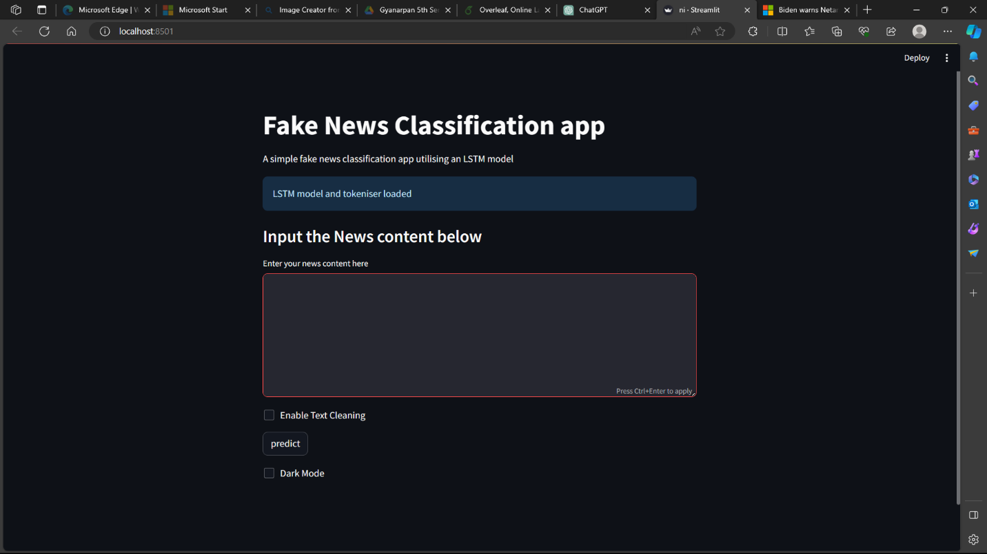

**Layout for the homepage of our WebApp**

**Input is Given & our LSTM model is loading into the App and filtering out the authenticity of the news given**

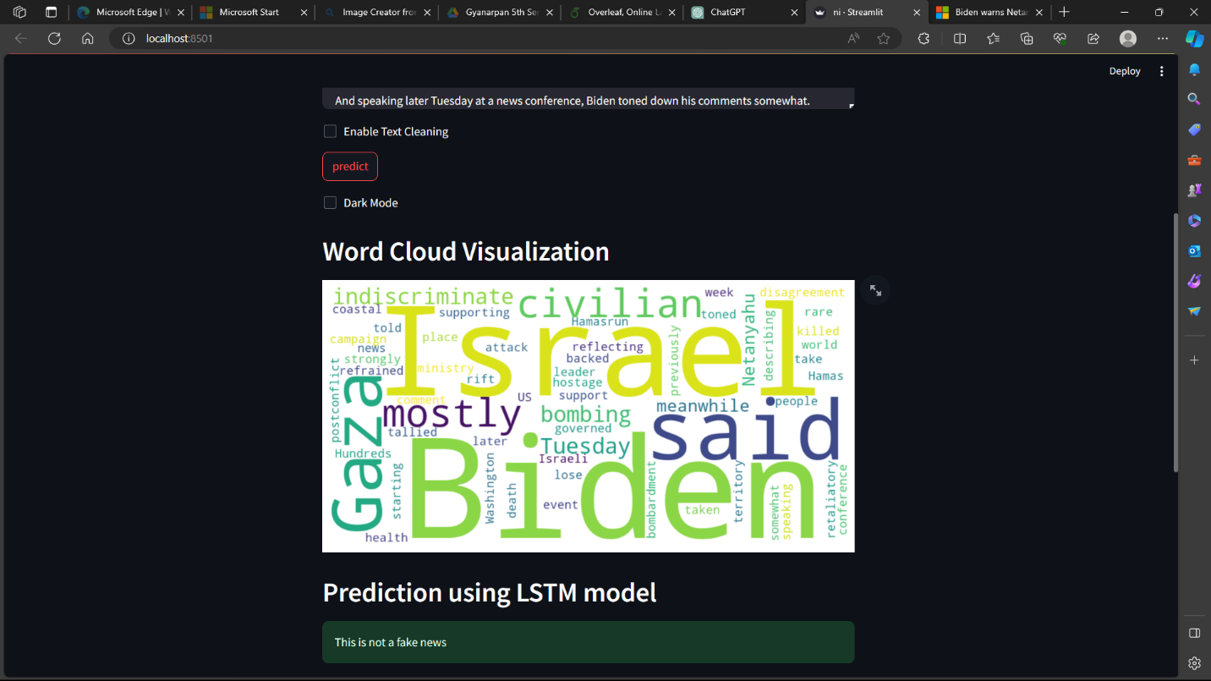

**Word Cloud is generated for the users to get an idea about which word was most frequently used. This will help highlight the topic of the news Newwithout reading the lengthy news article.**

**Prediction shows whether the news was fake or not in bar percentage. We can also enhance these features using the input tools given in our tab.**

**Also we have made a dark mode feature to enhance user experience and also made a login page for the users which will be linked to a secured database**